**Bilder från Logemötet 25 mars 2018**

[[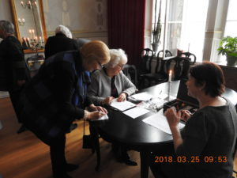](http://vasaorden.com/boras/files/2018/03/DSCN1494.jpg) [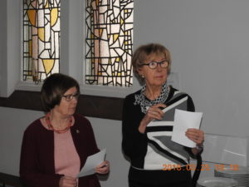](http://vasaorden.com/boras/files/2018/03/DSCN1505.jpg)](http://vasaorden.com/boras/files/2018/03/DSCN1494.jpg)

[[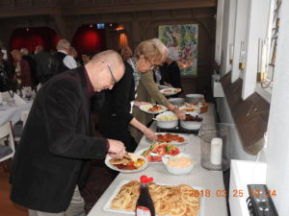](http://vasaorden.com/boras/files/2018/03/DSCN1507.jpg) [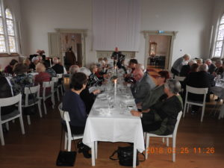](http://vasaorden.com/boras/files/2018/03/DSCN1517.jpg)](http://vasaorden.com/boras/files/2018/03/DSCN1507.jpg)

[[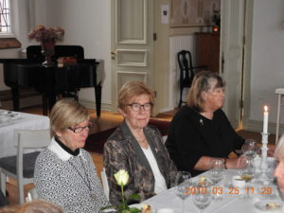](http://vasaorden.com/boras/files/2018/03/DSCN1525.jpg) [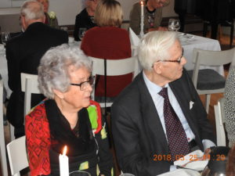](http://vasaorden.com/boras/files/2018/03/DSCN1526.jpg)](http://vasaorden.com/boras/files/2018/03/DSCN1525.jpg)

[[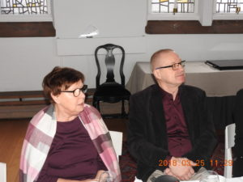](http://vasaorden.com/boras/files/2018/03/DSCN1528.jpg) [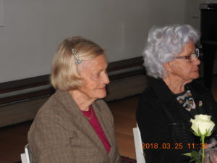](http://vasaorden.com/boras/files/2018/03/DSCN1529.jpg)](http://vasaorden.com/boras/files/2018/03/DSCN1528.jpg)

[[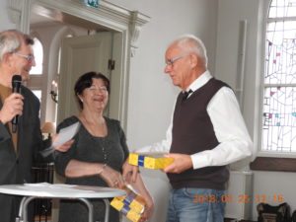](http://vasaorden.com/boras/files/2018/03/DSCN1533.jpg) [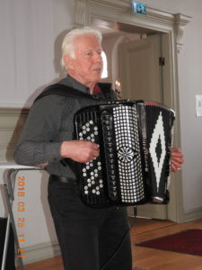](http://vasaorden.com/boras/files/2018/03/Ingvar-Helgesson-e1522097552924.jpg)](http://vasaorden.com/boras/files/2018/03/DSCN1533.jpg)